Code:-
import cv2
import numpy as np
import matplotlib.pyplot as plt
# 1. Read image using image path
img = cv2.imread(r'D:\\ict\\sem5\\DSIP\\lab & theory session\\assignmentAndOEQ\\Experiment 10\\image.jpg', 0)
# 2. Fourier Transform
F = np.fft.fftshift(np.fft.fft2(img))
M, N = img.shape
# 3. Create frequency distance matrix
u, v = np.meshgrid(np.arange(N)-N//2, np.arange(M)-M//2)
D = np.sqrt(u**2 + v**2)
# 4. Low-Pass and High-Pass Filters
LPF = D < 30
HPF = D >= 30
# 5. Apply filters
smooth = np.abs(np.fft.ifft2(np.fft.ifftshift(F * LPF)))
high_pass = np.abs(np.fft.ifft2(np.fft.ifftshift(F * HPF)))
sharp = np.clip(img.astype(float) + high_pass, 0, 255)
# 6. Display images
plt.figure(figsize=(12, 4))
plt.subplot(1, 3, 1)
plt.imshow(img, cmap='gray')
plt.title('Original Image')
plt.axis('off')
plt.subplot(1, 3, 2)
plt.imshow(smooth, cmap='gray')
plt.title('LPF - Smoothening')
plt.axis('off')
plt.subplot(1, 3, 3)
plt.imshow(sharp, cmap='gray')
plt.title('HPF - Sharpening')
plt.axis('off')
plt.show()
Observation:-
The Fourier Transform converts the original image into the frequency domain. The Low-Pass Filter (LPF) removes high-frequency components, resulting in a smoother and blurrier image. The High-Pass Filter (HPF) retains high-frequency components, highlighting edges and fine details. Adding the high-pass filtered image to the original image enhances sharpness and makes details more visible.
Output:-
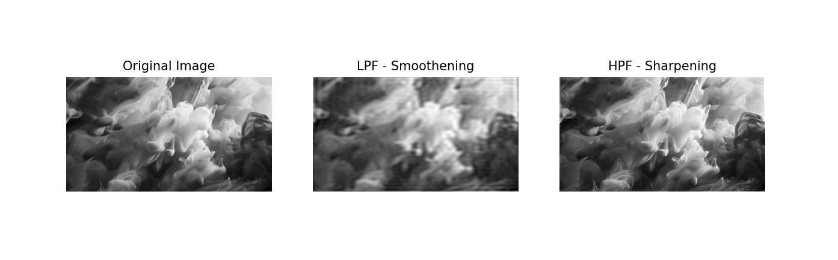
Conclusion:-
Thus, Low-Pass and High-Pass Filters were successfully implemented using the Fourier Transform. The LPF is used for image smoothening, while the HPF helps enhance edges and fine details for image sharpening.

